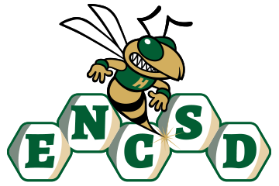
Board of Trustees

Public Notice of Proposed Policy for Comment
Eastern North Carolina School for the Deaf invites public comment on the following proposed policies. In accordance with applicable state law, policies are posted for stakeholder review and feedback prior to adoption by the Board of Trustees.
Policy Title/Number
Drugs and Alcohol 4325
Summary of Policy
The proposed policy establishes clear expectations prohibiting the unlawful possession, use, distribution, sale, manufacture, or being under the influence of alcohol, illegal drugs, controlled substances, and unauthorized medications by students on school property, in school vehicles, and at school-sponsored activities. The policy is designed to promote a safe, healthy, and drug-free educational environment while supporting prevention, intervention, and student well-being. Key components of the policy include:
- A prohibition on the possession, use, sale, distribution, manufacture, or transmission of alcohol, illegal drugs, controlled substances, counterfeit substances, and drug paraphernalia by students while under the jurisdiction of the school.
- A prohibition against students attending school or school-sponsored activities while impaired or under the influence of alcohol or unauthorized drugs.
- Definitions and examples of prohibited substances, including controlled substances, alcoholic beverages, inhalants, cannabis products where prohibited by law, and unauthorized prescription or over-the-counter medications.
- Procedures for responding to suspected violations, including investigation, search and seizure when legally permissible, confiscation of prohibited items, and referral to law enforcement or emergency services when appropriate.
- Expectations for the safe administration and management of student medications in accordance with Board policy and applicable health services procedures.
- A commitment to providing age-appropriate education, prevention programming, and intervention strategies to reduce substance use and promote healthy decision-making.
- Coordination with related Board policies governing student conduct, student discipline, tobacco and vaping products, student health services, and safe school requirements.
- Assurance that disciplinary actions and interventions will be administered fairly, consistently, and in accordance with the rights and protections afforded to students under applicable federal and state laws.
ENCSD is committed to ensuring that all parents and guardians, including those who are Deaf or Hard of Hearing, have disabilities, or have limited English proficiency, can meaningfully engage with the school. All notices, policies, and opportunities for participation will be provided in accessible formats and languages, consistent with ADA, Section 504, and federal guidance.
How to Submit Comments
Please submit written comments via email to: mandy.armstrong@encsd.k12.nc.us
Or mail to:
Eastern North Carolina School for the Deaf
Attn: Mandy Armstrong
1311 US-301 South
Wilson, NC 27893
Deadline for Comments:
All comments must be received by August 18, 2026, 12 PM to be considered by the Board.

