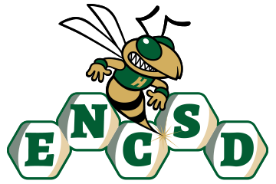
Board of Trustees

Public Notice of Proposed Policy for Comment
Eastern North Carolina School for the Deaf invites public comment on the following proposed policies. In accordance with applicable state law, policies are posted for stakeholder review and feedback prior to adoption by the Board of Trustees.
Policy Title/Number
Tobacco Products – Students 4320
Summary of Policy
The proposed policy establishes clear expectations prohibiting the possession, use, distribution, sale, or promotion of tobacco products and tobacco-related devices by students on school property, in school vehicles, and at school-sponsored activities. The policy is intended to promote a healthy, safe, and tobacco-free environment that supports student well-being and complies with applicable state and federal laws. Key components of the policy include:
- A prohibition on student possession, use, distribution, sale, or display of tobacco products, electronic cigarettes (e-cigarettes), vaping devices, nicotine delivery systems, and related paraphernalia while on campus, in school vehicles, or at any school-sponsored event.
- Definitions of prohibited tobacco and nicotine products, including traditional combustible tobacco products and emerging electronic nicotine delivery systems.
- Expectations that all students comply with North Carolina laws and Board policies designed to protect the health and safety of the school community.
- Procedures for addressing violations through age-appropriate and equitable disciplinary responses, including educational and restorative interventions when appropriate.
- Provisions for confiscation and proper disposal of prohibited tobacco and vaping products in accordance with applicable law and school procedures.
- Coordination with related Board policies governing student conduct, student discipline, health services, and substance use prevention.
- Support for prevention and awareness initiatives that educate students about the health risks associated with tobacco, nicotine, and vaping products.
- Assurance that disciplinary actions and interventions will be administered fairly, consistently, and without discrimination.
ENCSD is committed to ensuring that all parents and guardians, including those who are Deaf or Hard of Hearing, have disabilities, or have limited English proficiency, can meaningfully engage with the school. All notices, policies, and opportunities for participation will be provided in accessible formats and languages, consistent with ADA, Section 504, and federal guidance.
How to Submit Comments
Please submit written comments via email to: mandy.armstrong@encsd.k12.nc.us
Or mail to:
Eastern North Carolina School for the Deaf
Attn: Mandy Armstrong
1311 US-301 South
Wilson, NC 27893
Deadline for Comments:
All comments must be received by August 18, 2026, 12 PM to be considered by the Board.

