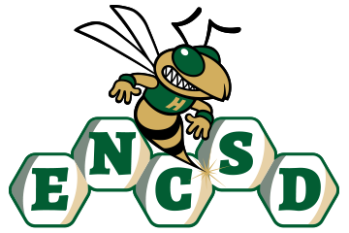
Board of Trustees

Public Notice of Proposed Policy for Comment
Eastern North Carolina School for the Deaf invites public comment on the following proposed policies. In accordance with applicable state law, policies are posted for stakeholder review and feedback prior to adoption by the Board of Trustees.
Policy Title/Number
Student Dress Code 4316
Summary of Policy
The proposed policy establishes standards for student dress and personal appearance that support a safe, respectful, and disruption-free educational environment at ENCSD. The policy is designed to balance student self-expression with the school’s responsibility to maintain health, safety, effective communication, and an atmosphere conducive to learning. Key components of the policy include:
- A clear statement that students are expected to dress in a manner that is appropriate for the school setting and does not interfere with the educational process or the safety and well-being of others.
- Standards prohibiting clothing, accessories, or personal items that are obscene, profane, discriminatory, gang-related, sexually explicit, or that promote violence, illegal activities, drugs, alcohol, tobacco, vaping products, or other prohibited substances.
- Expectations that student attire will not create health or safety hazards or substantially disrupt school operations or instructional activities.
- Recognition of students’ rights to express their individuality and cultural identity, provided such expression does not violate school rules or infringe upon the rights of others.
- Reasonable accommodations for students based on disability, medical necessity, religious beliefs, or other legally protected circumstances, consistent with applicable federal and state laws.
- Procedures for addressing dress code concerns in a respectful, equitable, and non-discriminatory manner that minimizes disruption to the student’s educational experience.
- Assurance that dress code standards will be applied consistently and without discrimination based on race, color, national origin, sex, gender identity, disability, religion, or other protected characteristics.
- Communication of dress code expectations to students and families through the Student/Family Handbook and other accessible school communications.
ENCSD is committed to ensuring that all parents and guardians, including those who are Deaf or Hard of Hearing, have disabilities, or have limited English proficiency, can meaningfully engage with the school. All notices, policies, and opportunities for participation will be provided in accessible formats and languages, consistent with ADA, Section 504, and federal guidance.
How to Submit Comments
Please submit written comments via email to: mandy.armstrong@encsd.k12.nc.us
Or mail to:
Eastern North Carolina School for the Deaf
Attn: Mandy Armstrong
1311 US-301 South
Wilson, NC 27893
Deadline for Comments:
All comments must be received by August 18, 2026, 12 PM to be considered by the Board.

