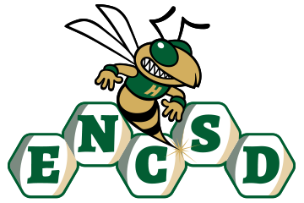
Board of Trustees

Public Notice of Proposed Policy for Comment
Eastern North Carolina School for the Deaf invites public comment on the following proposed policies. In accordance with applicable state law, policies are posted for stakeholder review and feedback prior to adoption by the Board of Trustees.
Policy Title/Number
Integrity and Civility 4310
Summary of Policy
The proposed policy establishes expectations for maintaining a culture of integrity, civility, and mutual respect throughout the ENCSD community. The policy promotes positive interactions among students, employees, parents, volunteers, contractors, and visitors while supporting a safe and orderly educational environment that reflects the values of the school. Key components of the policy include:
- A commitment to fostering an environment characterized by honesty, courtesy, professionalism, and respect for the rights and dignity of others.
- Expectations that all members of the ENCSD community communicate and interact in a civil and respectful manner, both in person and through electronic communication.
- Standards of conduct that encourage constructive conflict resolution and discourage disruptive, abusive, threatening, intimidating, or disrespectful behavior.
- Recognition that maintaining a positive school climate is a shared responsibility of students, employees, families, and community partners.
- Procedures for addressing conduct that undermines the safety, order, or effective operation of the school or interferes with the rights of others.
- Coordination with related Board policies governing student conduct, employee standards of conduct, bullying and harassment, nondiscrimination, and school safety.
- Expectations that school officials will model integrity and professionalism while ensuring that all individuals are treated fairly and consistently.
- Protections against retaliation for individuals who, in good faith, report violations of Board policies or cooperate in investigations or complaint processes.
ENCSD is committed to ensuring that all parents and guardians, including those who are Deaf or Hard of Hearing, have disabilities, or have limited English proficiency, can meaningfully engage with the school. All notices, policies, and opportunities for participation will be provided in accessible formats and languages, consistent with ADA, Section 504, and federal guidance.
How to Submit Comments
Please submit written comments via email to: mandy.armstrong@encsd.k12.nc.us
Or mail to:
Eastern North Carolina School for the Deaf
Attn: Mandy Armstrong
1311 US-301 South
Wilson, NC 27893
Deadline for Comments:
All comments must be received by August 18, 2026, 12 PM to be considered by the Board.

