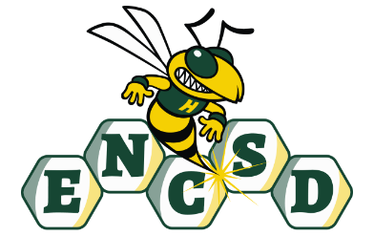

Dr. Michele Handley

School Director

Cheryl Iannucci
Principal

Eastern North Carolina School for the Deaf
Wilson, North Carolina

The Eastern North Carolina School for the Deaf is hosting the Mason Dixon Girls’ Volleyball Tournament!
Would you like to support the ENCSD? Would you like to grow your business? Would you like to do both at the same time? Well, here’s how!
The Mason Dixon Conference is made of up of 10 Schools for the Deaf in the Southeastern region. It is an opportunity for students to make friends and compete against other deaf high schools. The volleyball tournament will be on the campus of the ENCSD October 10 through 12, 2024. We are selling advertisement space to help us make it a great experience!
(Please circle the ad size you wish to purchase.)
1 Quarter Page Ad = $20.00
1 Third Page Ad = $30.00
1 Half Page Ad = $40.00
1 Full Page Ad = $75.00
Company Name:_____________________________________________________
Company email address: ______________________________________________
Company phone number: ______________________________________________
Amount Paid: ______________________
Please send a jpeg of your ad to heather.goins@esdb.dpi.nc.gov or attach images/business card to this paper for us to scan and create your ad.
The last day to submit your logo September 13, 2024. Please make checks payable to the Eastern North Carolina School for the Deaf.

